1. In the last lecture, we saw the rest services we needed for the bank app.
2. **Agenda**: Now, we’re going to test the REST Controller with the default configuration.
3. Now we have 6 services and by default Spring Security would secure all the services.
4. 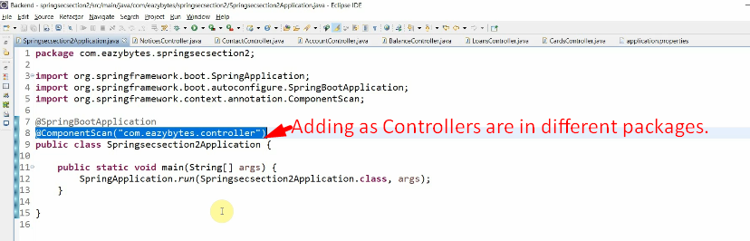
5. 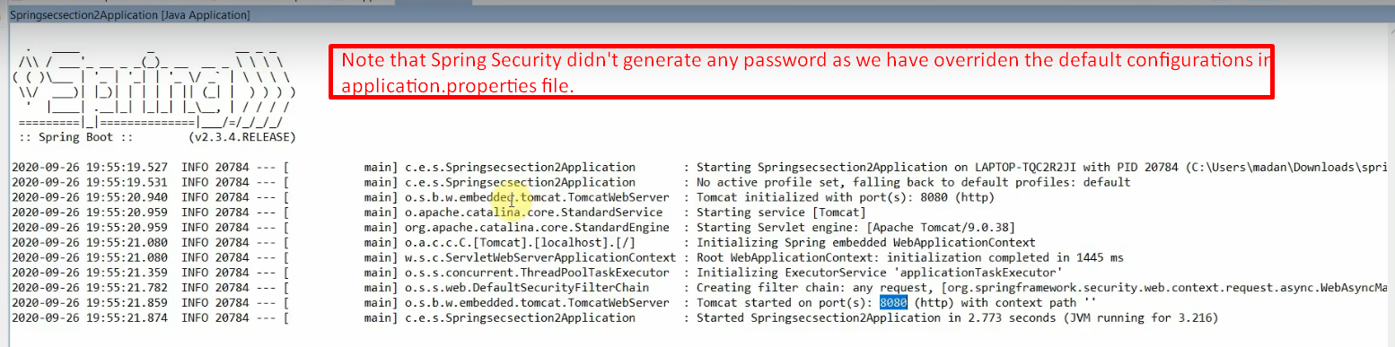
6. 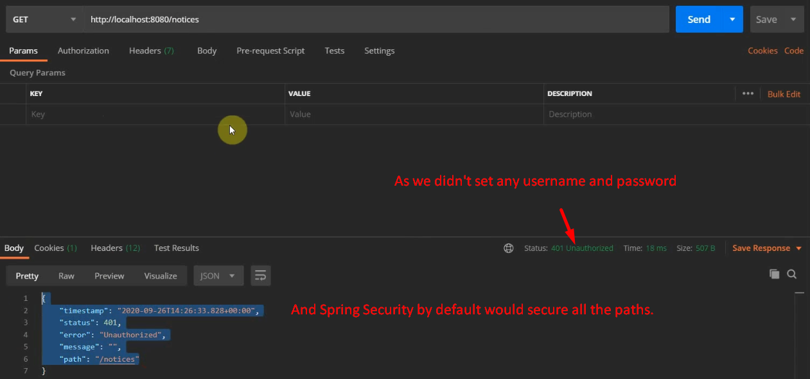
7. By default, Spring Security is securing all the endpoints which is not our requirements as endpoints for contacts and notifications should be accessible by anyone with security.
8. Let’s see how to do this in next section.